Project Development Phase
Functional & Performance Test
Date | 08 October 2026
Team ID | 9100Smartgirls
Project Name | Streamlining IT Procurement: Automating Standard Laptop Orders with Flow Designer
Maximum Marks | 4 Marks

Functional & Performance Testing:
Project team shall fill the following information in functional and performance testing template.
S.No. | Parameter | Values | Screenshot
1. | Solution Summary | ServiceNow automation for standard laptop procurement using the Standard Laptop item in the Service Catalog and a Flow Designer flow named "Standard Laptop Task". The flow has the Service Catalog trigger and the Create Catalog Task action, which creates a configuration task for the Hardware assignment group.  Note: The flow is attached to the Standard Laptop catalog item through Process Engine, so it runs for orders of that item. | 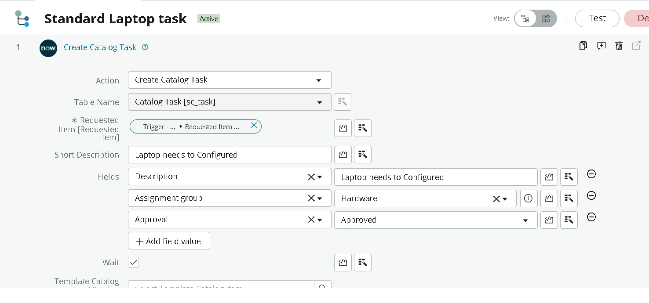
2. | Task Creation Accuracy | Test cases executed: 7 (TC-001 to TC-007, see the User Acceptance Testing document)  Passed: 6 of 7  Catalog task SCTASK0010001 was created under Requested Item RITM0010001 with Assignment Group Hardware and Approval Approved.  Open finding: Short Description is shown as "Laptop needs to be Configured" (capital C), see BG-001. | 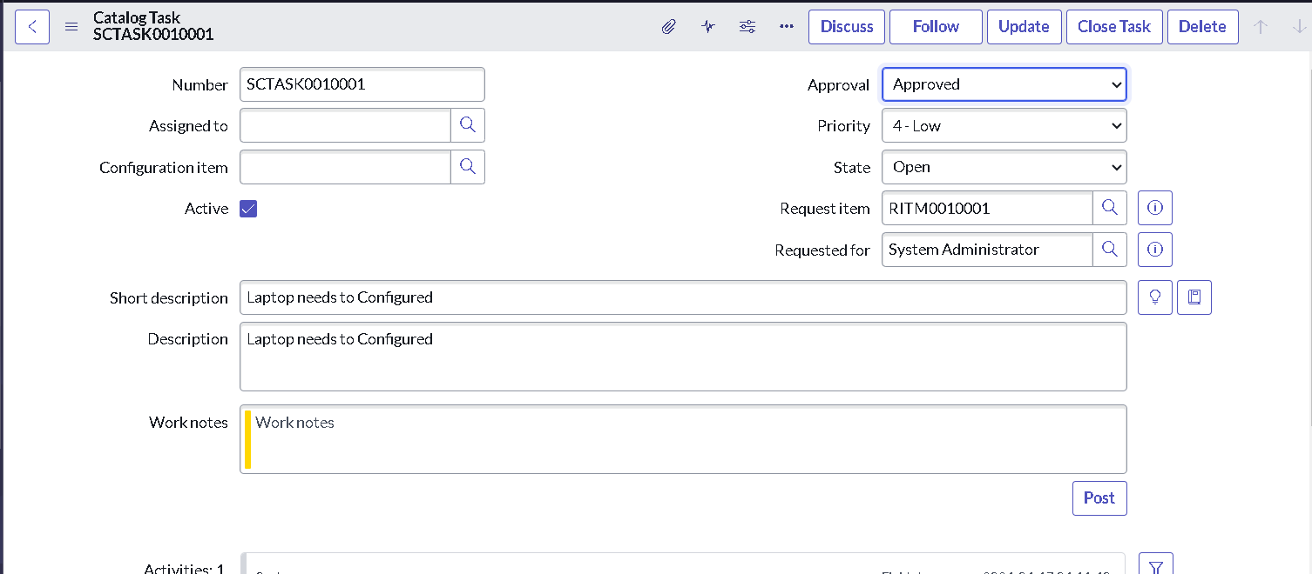
3. | Flow Execution | Trigger: Service Catalog (order of Standard Laptop)  Flow status: Active  Action executed: Create Catalog Task (Table: Catalog Task [sc_task]; Request Item: Requested Item record)  Result: Catalog Tasks (1) is listed under the Requested Item. | 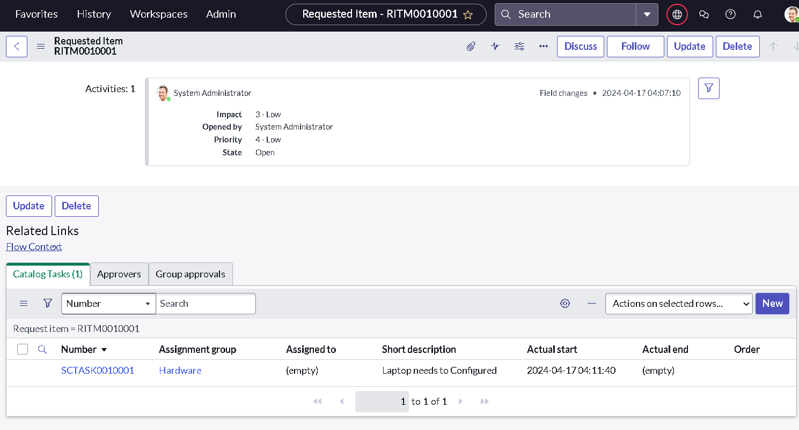
4. | Response Time | The request number is generated as soon as Order Now is clicked, and the catalog task is created by the flow without any manual action by the IT team. | 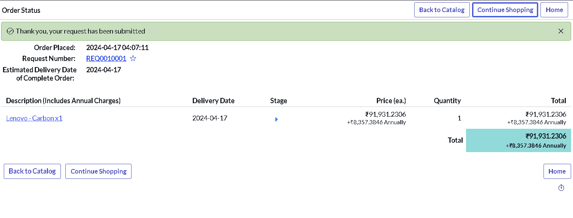
5. | Error Handling | The flow runs only for orders of the Standard Laptop item, so other catalog items are not affected. Flow Designer provides an error handler section in the flow. If the task is not created, the execution can be reviewed in Flow Designer and the configuration task can be created manually by the IT team. | 